Result of Q-2:

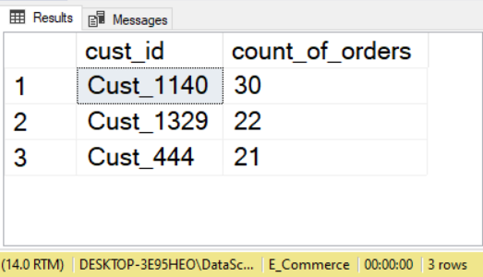

Result of Q-3:

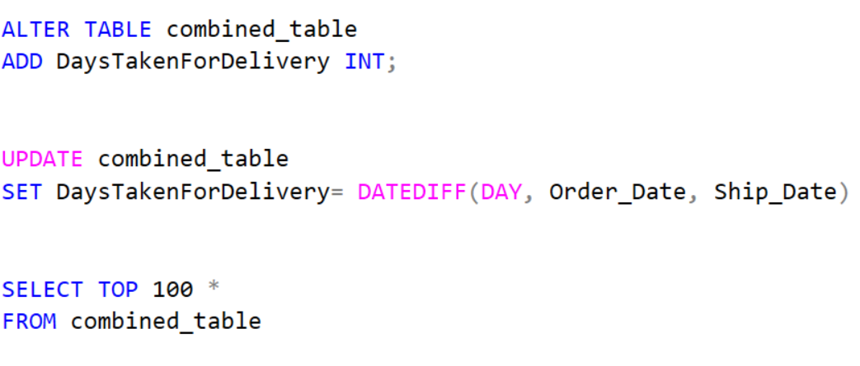

Result of Q-4:

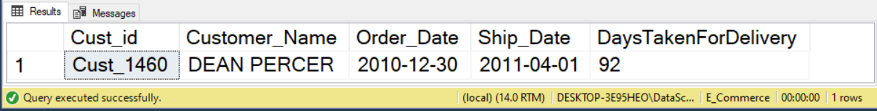

Result of Q-5:

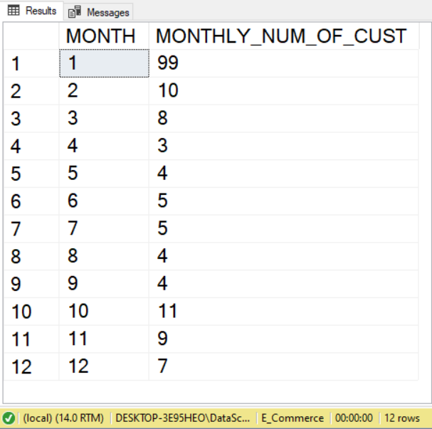

Result of Q-6:

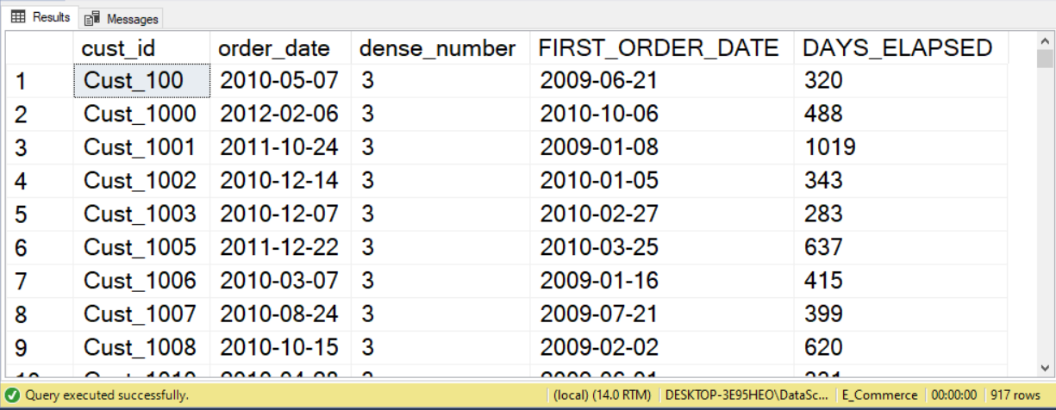

Result of Q-7:

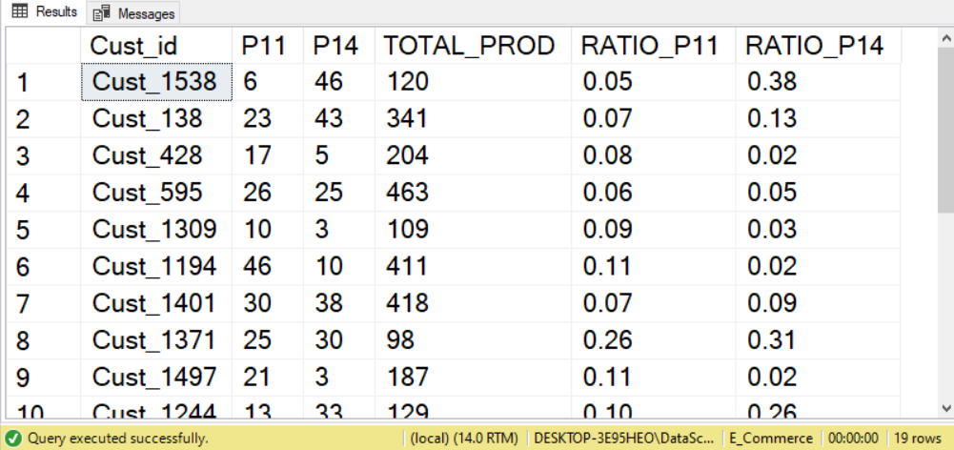

Customer Retention Analysis Phase:  
  
Result of Q-1:

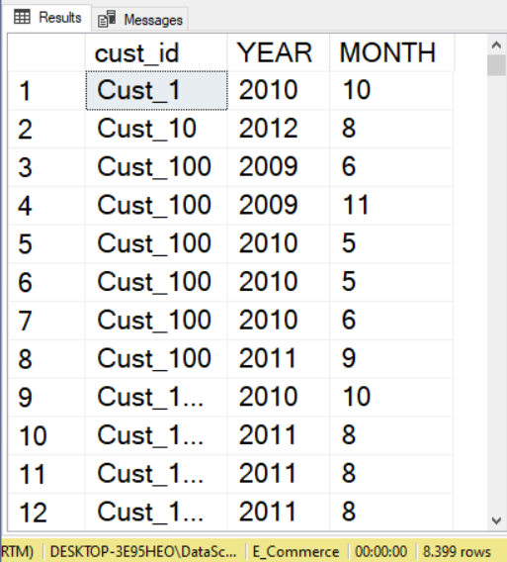

Result of Q-2:

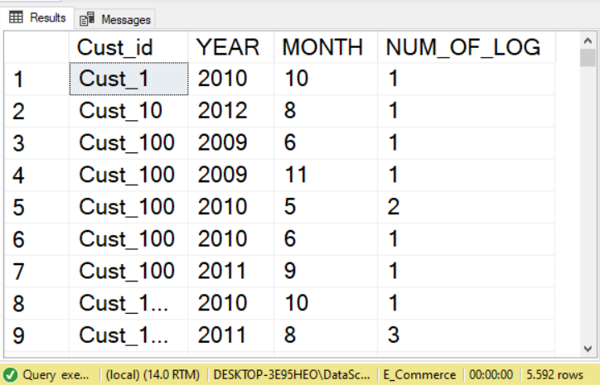

Result of Q-3:

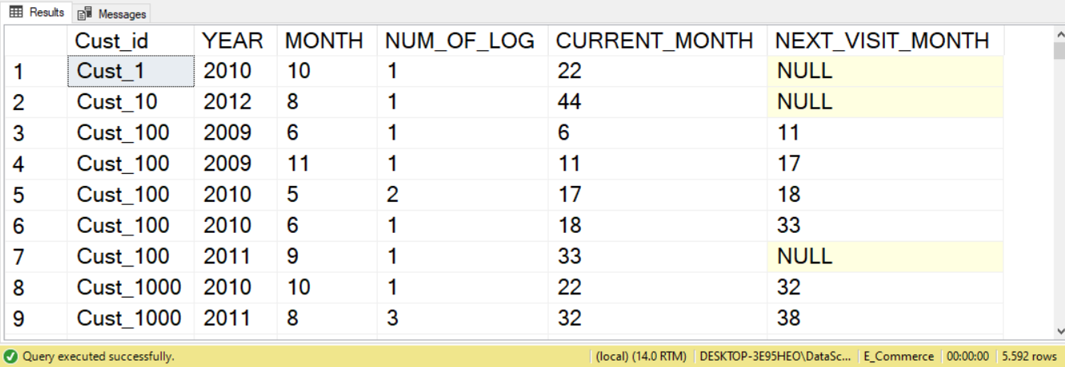

Result of Q-4: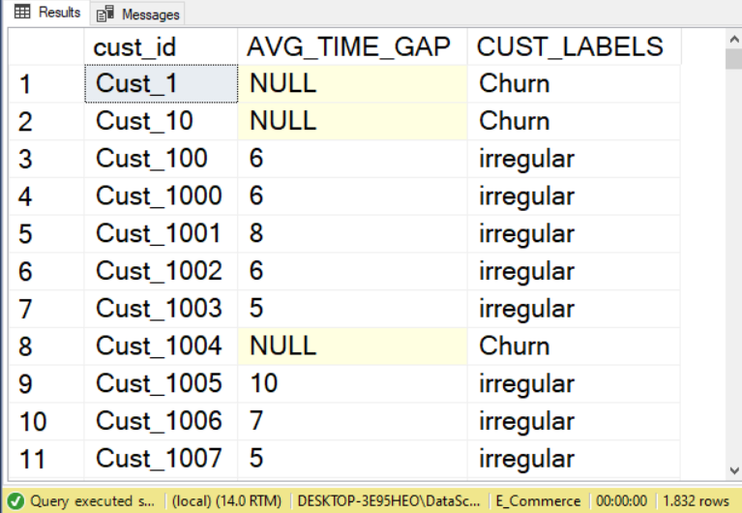

Result of Q-5:

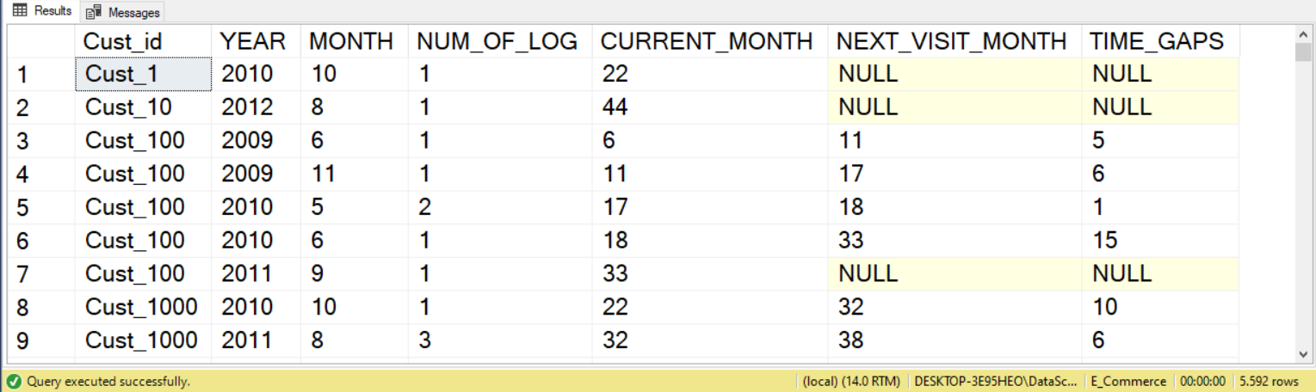

Month Wise Retention Rate:  
  
Result of Q-1:

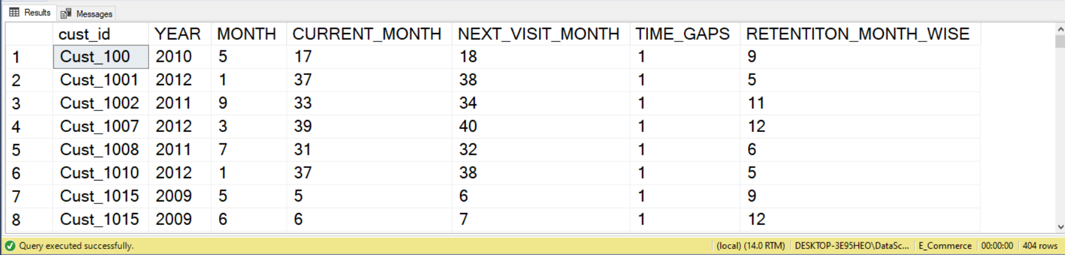

Result of Q-2:

